Title or Task: |   

Description:

Files Required
Suitable for Classes: | AIT • Multimedia • Cert II IT • Cert II Bus
Area: | Technology & Enterprise
Teacher: | Mr Peter Faulks

Timeline

Date Due:
Task Brief: | In class lesson

Outcomes:

Items highlighted in yellow are tasks for you to complete
Items in Blue italics are help tips

These pages are designed to show you how to use software packages; various software updates may have taken place so some pages will not apply to versions other than those listed here. In some cases data files may be required.

Job Analysis
Collect three (3) positions advertised in the paper that might interest you.
Positions 1 Choose any
1. For each position advertised, answer the following:
  - What qualifications are required?
  - What experience requirements are listed?
  - When does the position become available?
  - When do applications close?
  - What process or next stage do the applicants follow?
  - How many referees are required?
  - Any special conditions stipulated?
  - What is the address for you to send your resume to?
  - Who is the contact person advertising the position?
  - What salary or package is being offered?
  - Why does the position advertised interest you?
2. Apply for a position…
Add - what do you offer any future employers that most other candidates cannot offer? (Be creative)

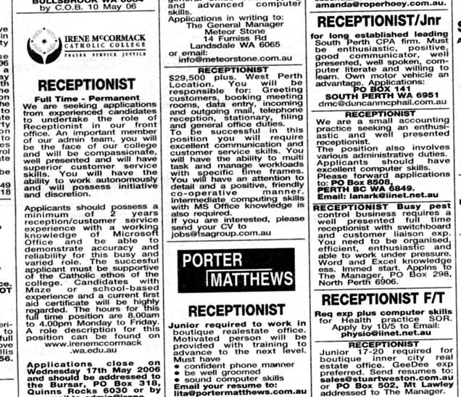

Positions 2 Choose any
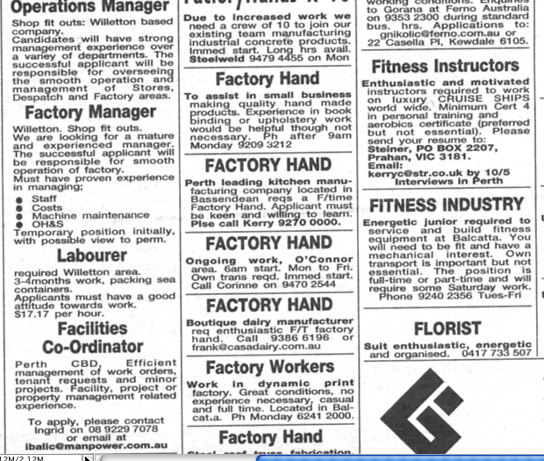

Positions 3 Choose any

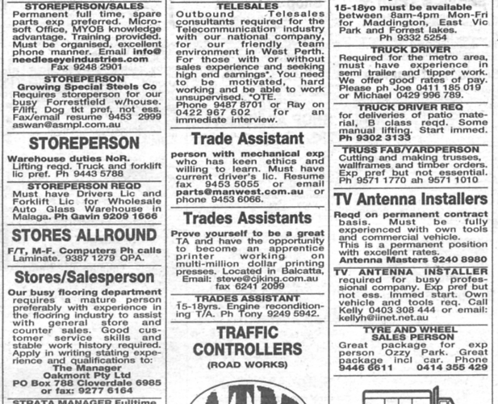

Positions 4 Choose any

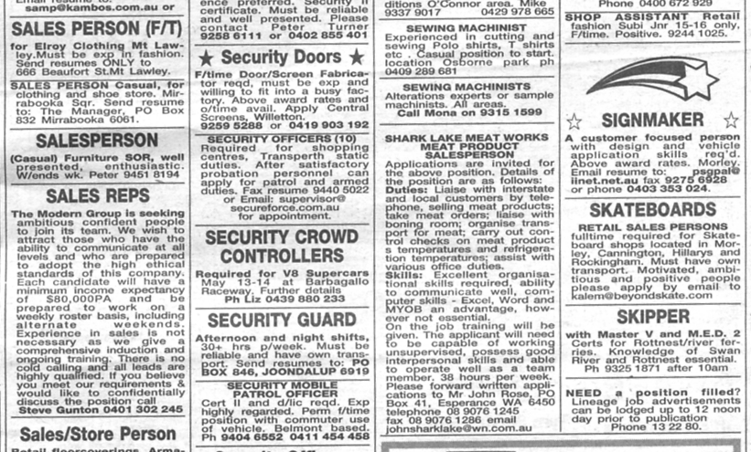

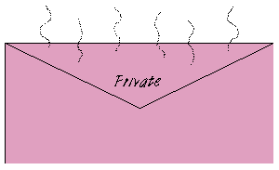
One student, desperate to get into advertising, had been rejected by the main London agencies, so he decided to try a different approach. He bought some pink envelopes and a small bottle of expensive perfume. He placed his CV in the envelopes and wrote "Private" on the outside. He liberally sprinkled the envelopes with scent and posted them to the senior agency partner in several of the biggest agencies. When it arrived, nobody dared to open the letters and the graduate was offered several interviews - presumably for his daring. Note that again, we don't recommend that you try his technique!



